SCH3U

Test: Unit 1
Matter, Chemical Trends and Chemical Bonding
Name:____________________
Instructions:
You will have the entire period to complete the test (75 minutes)
The test is made up of 4 sections:
Section A – Multiple Choice / True and False
Section B – Matching
Section C – Short Answer
Section D – Long Answer
Please follow all the instructions
Please read all questions carefully
A mark breakdown of the test can be found after these instructions
Good Luck!

Mark Summary
Section | Knowledge  /Understanding | Thinking | Application | Communication | TOTAL
A
B
C
D
Sub‐Totals | / 31 | / 22 | / 16 | / 11 | / 80

Comments:

Section A – Multiple Choice
Please read each question carefully and then circle the letter of the response that you feel is the most correct. (Approx. 10 min for multiple choice section – 1 min/question)
(1 mark each – K/U)

1) Which of the following ions always contain more than one item?
cations
multi-valent ions
poly-atomic ions
anions

2) What is the energy change that occurs when an electron is gained by an atom in the gaseous state?
ionization energy
electron affinity
ionization
electro-negativity

3) Which is a molecular compound?
NH₃
CaCl₂
NO³⁻
Na₂O

4) What type of bond is likely to form between the elements molybdenum, Mo and chlorine, Cl?
Non polar covalent
Polar covalent
Ionic
None of the above

5) Which of the following is true of DEET?
It is synthetically prepared
It is white and powdery solid
It will not painted surfaces
All of the above

6) Of the following attractions which is generally the weakest attractive force between particles?
Ionic bond
Covalent bond
Dipole - dipole force
London dispersion force

7) Which of the following substances is most likely to have hydrogen bonding?
Ammonia, NH₃ (g)
Methane, CH₄ (g)
Phosphine, PH₃ (g)
All of the above

8) Which property of the element decreases as you proceed from left to right across a row on the periodic table?
Atomic radius
Ionic radius
Ionization energy
Electron affinity

9) Which one of the following trends is incorrect?
a) Atomic mass always increases in a period.
b) Ionization energy always decreases in a group/family.
c) Atomic radius always increases in a group/family.
d) Number of protons always increases in a period.

10) Which one of the following is generally NOT a property of ionic compounds?
a) High melting points
b) High boiling points
c) Brittle in the solid state
d) Conducts electricity in the solid state

Section A – True/False
Please read the statements below and then indicate whether they are true or false by writing either true or false (Approximately 5 minutes for true/false section – 1 min/question). If you think the statement is false, rewrite it to make it true.
(1mark each - K/U)

Bohr’s model of the atom includes neutrons located in energy levels.

The noble gases exist as individual atom and are quite reactive.

Moving down a group, ionization energies tend to decrease.

The majority of known compounds are molecular.

The correct name for the compound (NH₃)₂SO₄ is ammonium sulphate.

Atomic radius is measurement of the size of an atom.

There are no attractions (bonds) between two metal atoms.

Section B – Matching ( 1 mark each – K/U)
Match the term on the left with the most appropriate definition on the right.

1. | Polar Covalent Bond |  | A | The energy that is needed to remove an electron from a neutral atom.
2. | Isotopes |  | B | A chemical bond in which two electrons are shared by two atoms.
3. | Electron Affinity |  | C | An arrangement of eight electrons in the valence shell of an atom.
4. | Ionization Energy |  | D | A covalent bond between atoms that have  significantly different electro negativities. This results in the electron pair being shared unevenly.
5. | Atomic Radius |  | E | A positively or negatively charged particle that results from a neutral atom or group of atoms giving up or gaining electrons
6. | Stable Octet |  | F | The distance from the nucleus of an atom to the approximate outer boundary of the cloud-like region of its electrons.
7. | Covalent Bond |  | G | Atoms of an element that are chemically similar but have different numbers of neutrons and thus, different mass numbers.
8. | Electro negativity |  | H | A relative measure of an atom’s ability to attract shared electrons in a chemical bond.

Section C – Short Answer
Answer the following questions in the space provided. Please be sure to show
complete answers. (Approx. 20 min for short answer section)

What are the three possible ways in which an atom can achieve a complete octet.
(3 marks – A)

Draw Bohr-Rutherford diagrams for atoms of the following elements: (3 marks - T/I)

Aluminum 27

Oxygen 16

Hydrogen 1

Draw Lewis diagrams for atoms of the following elements. (2 marks - T/I)

Silicon Chlorine

An aluminum atom contains 13 protons and 14 neutrons. (3 marks - K)

What is the atomic number of Aluminum?

What is the mass number of this Aluminum?

What energy change occurs when an atom gains electron and when atom loses an electron? (2 marks - T/I)

Give an example of an electrolyte and explain why it is classified as an electrolyte.
(2 marks - T/I)

Describe the “zero-sum rule” for writing chemical formula for ionic compounds.
(2 marks - C)
Name each of the following polyatomic ions. (3 marks – K/U)
SO₄⁻²

NO₃¹⁻

BrO₃¹⁻

List the three different types of intermolecular forces? Which of these types are referred as Van der Waals forces? ( 4 marks C )

A student records the following evidence in a lab book.
Unknown substance | Pure state | Solubility in water | Solution conductivity
I | solid | high | low
II | solid | low | low
III | solid | high | none
IV | solid | high | high

Which of the substances in the table above is most likely an ionic compound? Explain your answer. (3 marks - T/I)

For a science fair project, a student wants to design a simple device for removing certain gases from polluted air. He knows that polar molecules dissolve well in water, so he bubbles polluted air through a jug of water to remove unwanted gases. For his project, the student uses air containing the following gases: (4-marks - T/I)
1. N_{2(g)} | 5. CH_{4(g)}
2. O_{2(g)} | 6. OCl_{2(g)}
3. HF_{(g)} | 7. C₃H_{8(g)}
4. NH_{3(g)} | 8. CH₃OCH_{3(g)}
List the gases that will dissolve by writing down their corresponding numbers.

Why do you think it is important for chemists around the world to decide on a standardized naming system for chemical compounds? (2 Marks – A)

Section D – Long Answer
Read the questions carefully and then provide your answer in the spaces provided.
(Approx. 20 min for long answer section)

Examine the following graph and answer the questions below: (A)
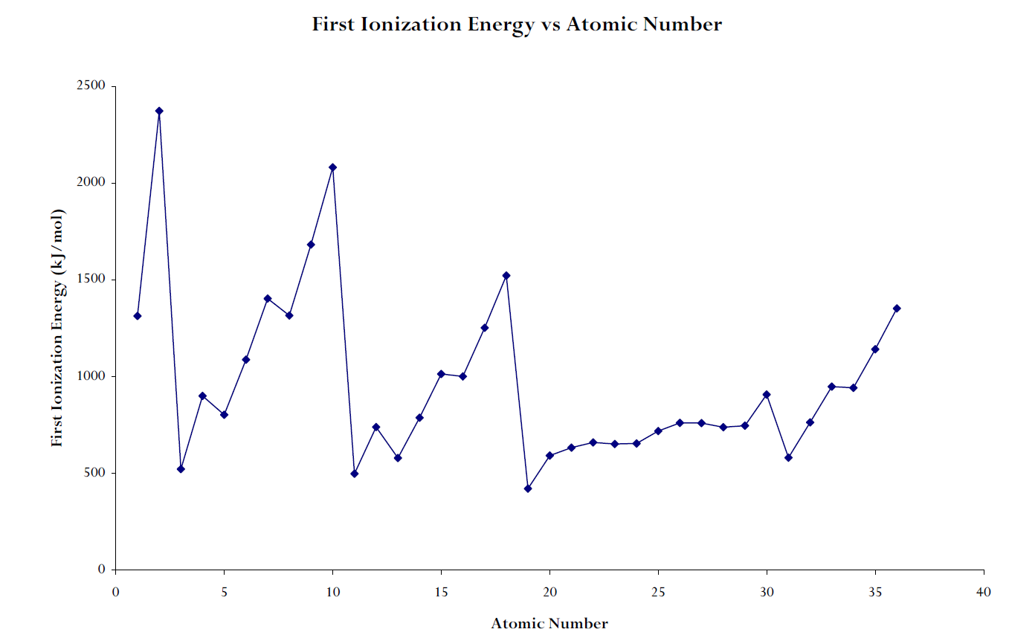
a) What is the trend (from L to R) across a period? (1 mark)

b) Using the three major factors discussed in class, explain why this trend occurs. (3 marks)

c) What is the trend from top to bottom in a group? ( 1 mark )

d) Using the three major factors discussed in class, explain why this trend occurs.
(3 marks)

Use the information given below to calculate the average atomic mass of element X
(3 marks - A)

Isotope | Abundance (%) | Mass (u or g/mol)
³⁰²X | 12.64 | 302.04
³⁰⁴X | 18.23 | 304.12
³⁰⁶X | 69.13 | 305.03

Determine the shape of the following molecules by drawing a Lewis structure and considering the distribution of electron pairs around the atoms. Then, determine ΔEN for the bonds. Finally, use the ΔEN and the shape to predict whether the molecule is polar or non-polar. (6 Marks – T/I)
a. H₂O b. CCl₄

Beakers (A) and (B) are filled with substances that are liquid at room temperature. The substance in beaker (A) experiences London dispersion forces. The substance in beaker (B) experience dipole-dipole interactions. Compare and contrast the two force types. Which substance will boil at a lower temperature and why? (5 marks – C)

